Rosalyn Eves * Press Kit
Images
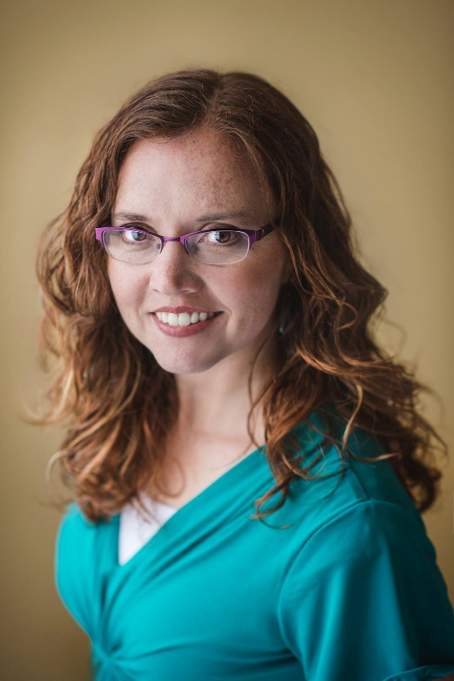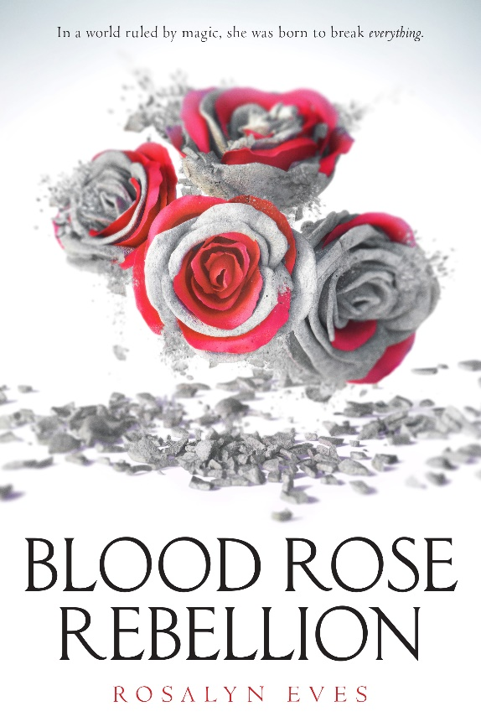
About the Book
Born into high British society, Anna Arden has been groomed for a position she will never fill. Though a member of the Luminates—the ruling class who use magic to exercise power—Anna cannot perform the simplest spells. But sometimes, by accident, she breaks them. After drawing unwanted attention from the magical elite, Anna is sent from England to her family’s once powerful but now oppressed native Hungary.
Her life might as well be over.
But Anna soon realizes that nothing is as it seems. The people around her hold dangerous secrets—from her aloof cousin Noémi to the fierce and handsome Romani Gábor to the magic-wielding Luminates. The society she’s known all her life is crumbling into discontent. And her lack of magic may mean more than she imagines.
In the company of nobles, revolutionaries, and Romanies, Anna must choose: deny her unique powers and cling to the life she’s always wanted, or embrace her gift, spark a rebellion, and change the world forever.
Blood Rose Rebellion is the first in a new fantasy trilogy bursting with magic, romance, and danger.

Author Bio (short)
Rosalyn Eves grew up in the Rocky Mountains, dividing her time between reading books and bossing her siblings into performing her dramatic scripts. As an adult, the telling and reading of stories is still one of her favorite things to do. When she’s not reading or writing, she enjoys spending time with her chemistry professor husband and three children, watching British period pieces, or hiking through the splendid landscape of southern Utah, where she lives. She dislikes housework on principle.
She has a PhD in English from Penn State, which means she also endeavors to inspire college students with a love for the English language. Sometimes it even works.
Rosalyn is represented by Josh Adams of Adams literary.
Author Bio (longer)
Rosalyn decided she wanted to be an author when she was eleven and spent the next several years writing very bad poetry and indifferent short stories. She wrote her first novella in junior high (bad enough that she has blocked out most of it, though her sister likes to quote parts of it at her when she wants to torment her), and her first novel in high school.
She lost a little bit of direction in college—after revising her (very long) novel, she set aside creative writing to focus on school. She did spend a semester in England, which only inflamed a life-long Anglophilia, and spent three weeks afterward backpacking across Europe, where she encountered Budapest for the first time. She took a year-and-a-half hiatus to live in Hungary, where she fell in love with the people, the language, and the culture.
After graduating with a degree in honors English, she went to graduate school at Penn State, where she earned her MA and PhD in English (with an emphasis in rhetoric and composition). Not so incidentally, she met her chemistry professor husband there (he was a fellow doctoral student), and had her first kid just before writing her dissertation.
When her second child was little, she realized that the book she meant to write someday would never happen if she didn’t start now, so in between teaching college courses and wrangling children, she wrote a middle-grade novel that taught her a lot about writing but didn’t otherwise go anywhere. Her next book was a young adult fantasy that combined all the things she loved—19th century history, magic, complicated stakes. That book got her an agent and a book deal and is coming out in March 2017.
If you had told her when she was eleven quite how long it would take to finally publish a book, she might have been daunted. But she’s grateful for the journey.

Social Media Links
http://www.rosalyneves.com/
http://www.facebook.com/rosalyneveswriter/
https://twitter.com/RosalynEves
http://rosalyneves.tumblr.com/
https://www.pinterest.com/rosalyneves/

Book Testimonials
"A magical tale unlike anything you've read before." —Bustle.com
“VERDICT: Despite its 400 page length, this is an enjoyable, fast-paced read with a likeable protagonist with whom readers will identify”—School Library Journal
“This richly imagined historical fantasy enchants while contemplating sexism, classism, and how to best effect social change. Intrigue, action, and a star-crossed romance abound, propelling this trilogy opener to a heart-breaking, yet hopeful conclusion.”—Publisher’s Weekly
“Romance sizzles and deadly magic crackles in Rosalyn Eves’s electrifying debut. Prepare to be spellbound.”—JULIE BERRY, award-winning author of The Passion of Dolssa and All the Truth That’s in Me
“Everything I love in a fantasy: history, noblemen, magic, romance, and a revolution. Blood Rose Rebellion had me charmed from the first page.”—VIRGINIA BOECKER, author of The Witch Hunter

